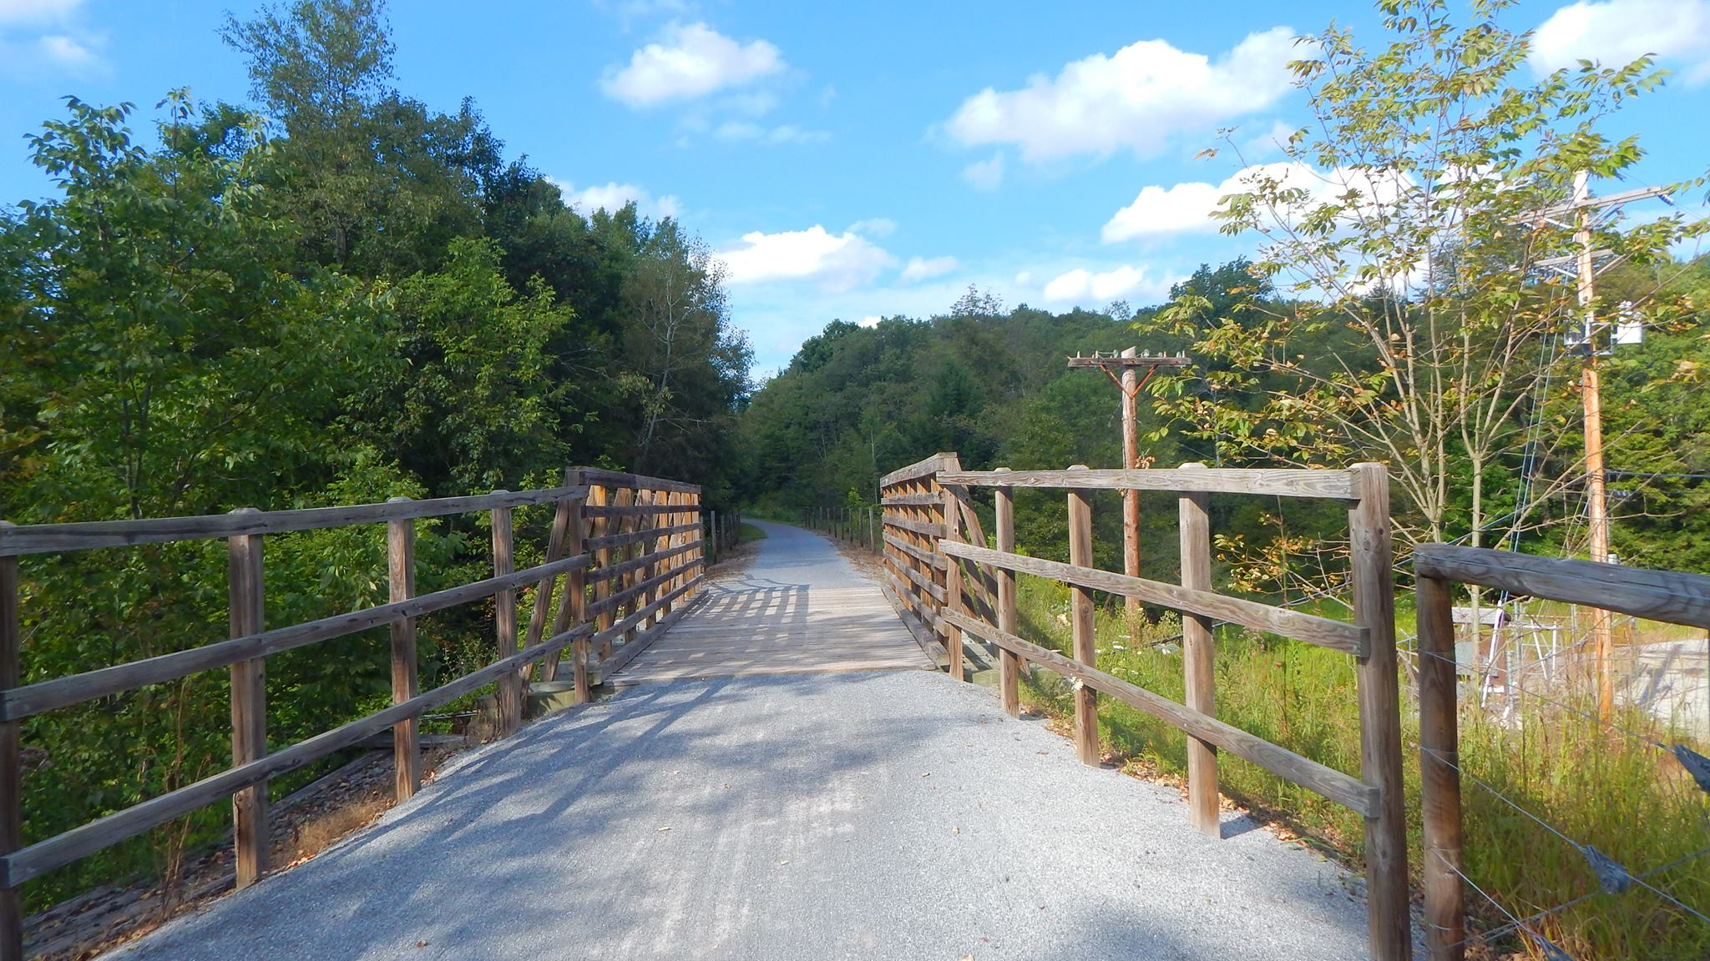

AGENDA
Cambria County Conservation & Recreation Authority
8:30 a.m., September 16, 2022
REGULAR BOARD MEETING

- Call to Order

- Pledge of Allegiance

- Roll Call

- Additions or Corrections to the Agenda by Board Members

- Floor Open to Public Comment on Agenda Items (including additions or corrections to the Agenda; Please clearly state your name)

- Commissioner’s Representative Report

- Correspondences:

  - None.

- Motion to Approve the Minutes of August 19, 2022 Regular Board Meeting

  - Corrections or Changes:

- Motion to Approve the Treasurer’s Report and Bills to be paid for the Month of September 2022:

  - Corrections or Changes:

- INFORMATIONAL ITEMS:

  - Maintenance Specialist Report

    - Report on the status of trail maintenance and development.

  - Program Coordinator Report

    - Report on the status of the Friends of the Trails Program and other trail related programming.

  - Rock Run

    - Report on updates at Rock Run.

  - Ghost Town Trail Report

    - Report on the start date for the 3-mile addition of the C & I Extension of the Ghost Town Trail.

    - Report on the status of the DCNR grant and the approach to find the match (DCED and AMLER).

  - Path of the Flood Trail Report

    - Report on the status of the Front Street property.

    - Report on the recent mudslide 0.6 miles from Fifficktown.

    - Report on the status of the trail extension to the breast of the dam.

  - Jim Mayer Riverswalk Trail Report

    - Report on status of underground tank.

    - Report on status of Riverside parking area.

    - Report on status of Somerset Street properties.

  - RAISE Grant

    - Report on the status of the trail projects through the City of Johnstown RAISE grant.

  - Duman Lake Trail Report

    - Report on status of bridge with Center for Metal Arts.

    - Report on installation of wayfinding signs between C & I Extension and Duman Lake County Park.

  - Report on status of Route 53 Rail into Cresson.

    - No update.

- NEW BUSINESS:

  - Path of the Flood Trail Connection: Motion to accept the bid from Berkebile Excavating, 907 Tire Hill Road, Johnstown, in the amount of $145,000 to construct the connection from the end of Amsite Road to the south abutment of the breast of the dam along the Path of the Flood Trail.

  - Hiring of Maintenance Specialist 2: Motion to authorize Maintenance Specialist 2 position to be hired at the recommendation of the hiring committee.

  - Cost of Living Adjustments: Motion to approve cost of living and performance incentive adjustments for all CCCRA staff members at a minimum of 3.5% due to cost of living increases, exemplary performance and economic inflation, to begin on the next regular pay cycle, September 16, 2022.

- Any further public comment (Please clearly state your name)

- ANNOUNCEMENT(S)

  - The next regularly scheduled meeting and reorganizational meeting of the Cambria County Conservation & Recreation Authority will take place on Friday, October 21, 2022, at 8:30 a.m. at Young People’s Community Center, 300 Prave Street, Ebensburg, PA 15931; Telephone No.: (425)436-6317; Access Code: 298266

- MOTION TO ADJOURN

