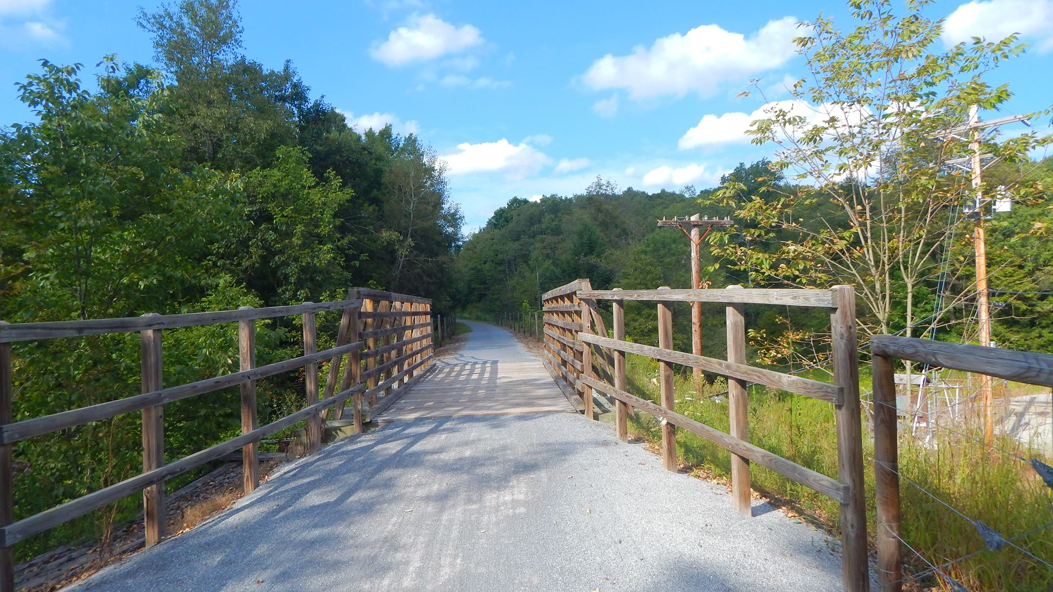

AGENDA
Cambria County Conservation & Recreation Authority
8:30 a.m., January 20, 2023
REGULAR BOARD MEETING

- Reorganizational Meeting

- Call to Order

- Pledge of Allegiance

- Roll Call

- Additions or Corrections to the Agenda by Board Members

- Floor Open to Public Comment on Agenda Items (including additions or corrections to the Agenda; Please clearly state your name)

- Commissioner’s Representative Report

- Correspondences:

  - None.

- Motion to Approve the Minutes of December 16, 2022 Regular Board Meeting

  - Corrections or Changes:

- Motion to Approve the Treasurer’s Report and Bills to be paid for the Month of January 2023:

  - Corrections or Changes:

- INFORMATIONAL ITEMS:

  - Maintenance Specialist Report

    - Report on the status of trail maintenance and development.

  - Program Coordinator Report

    - Report on the status of the Friends of the Trails Program and other trail related programming.

  - Rock Run

    - Report on meeting on 1/17/23 with DCNR and CPV.

    - Report on updates at Rock Run.

  - Ghost Town Trail Report

    - Report on the status of the 3-mile addition of the C & I Extension of the Ghost Town Trail.

    - Report on the status of AMLER grant to match DCNR grant.

    - Report on the First Energy power line replacement project.

    - Report on traffic accident on Edwards Street.

    - Report on Twin Rocks bridge.

  - Path of the Flood Trail Report

    - Report on the status of the trail extension to the breast of the dam.

    - Report on trail damage due to weather.

  - Jim Mayer Riverswalk Trail Report

    - Report on status of underground tank.

    - Report on Penelec project removing trees on the Riverside section of the Jim Mayer Trail.

    - Report on status of the Roberts Property.

    - Report on Sheesley Property.

- NEW BUSINESS:

  - Purchase of Laptop
Motion to approve the purchase of a laptop, not to exceed $2,000.00.

  - Personnel Adjustment
Motion to approve the adjustment of employment status of probationary to full time for Mr. Cruley.

  - Personnel Compensation Adjustments
Motion to approve the adjustment of salaries for the current 4 employees, not to exceed $900 collectively per month.

  - 501c3 Status
Motion to authorize our attorneys to investigate creating a 501c3 organization for the Friends of the Trails Program.

- Any further public comment (Please clearly state your name)

- ANNOUNCEMENT(S)

  - The next regularly scheduled meeting and reorganizational meeting of the Cambria County Conservation & Recreation Authority will take place on Friday, February 17, 2023, at 8:30 a.m. at Young People’s Community Center, 300 Prave Street, Ebensburg, PA 15931.

- MOTION TO ADJOURN

