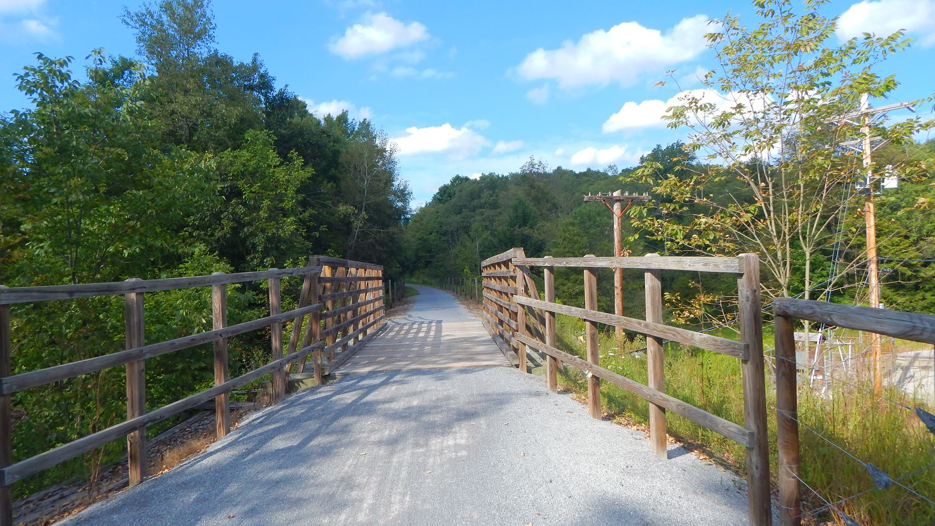

AGENDA
Cambria County Conservation & Recreation Authority
8:30 a.m., May 17, 2024
REGULAR BOARD MEETING

- Call to Order

- Pledge of Allegiance

- Roll Call

- Additions or Corrections to the Agenda by Board Members

- Floor Open to Public Comment on Agenda Items (including additions or corrections to the Agenda; Please clearly state your name)

- Commissioner’s Representative Report

- Correspondences:

  - None.

- Motion to Approve the Minutes of the April 19, 2024 Regular Board Meeting:

  - Corrections or Changes:

- Motion to Approve the Treasurer’s Report and Bills to be paid for the Month of May 2024:

  - Corrections or Changes:

- INFORMATIONAL ITEMS:

  - Maintenance Specialist Report

    - Report on the status of trail maintenance and development.

  - Program Coordinator Report

    - Report on the status of the Friends of the Trails Program and other trail related programming.

  - Rock Run

    - Report on request from CPV.

    - Report on updates at Rock Run.

  - Ghost Town Trail Report

    - Report on the status of AMLER grant to match DCNR grant.

    - Report on property use update at Red Mill Road/PA Watersheds grant.

    - Report on washout between Twin Rocks and Vintondale/Chapter 105 application/Chapter 11 Permit.

    - Report on the status of the 3-mile extension close out.

    - Report on the status of the Joseph Dushaw bequest.

    - Report on the status of Indiana County Parks & Trails maintenance.

    - Report on the status of washouts along the trail.

  - Path of the Flood Trail Report

    - Report on trail signage through 9/11 Memorial Trail and South Fork Historical Society.

    - Report on potential COLCOM grant.

    - Report on trail washouts along Stineman section.

    - Report on 9/11 Trail Alliance Grant

  - Jim Mayer Riverswalk Trail Report

    - Report on progress of Jim Mayer Bridge Street trailhead project.

    - Report on new washouts along the Jim Mayer Trail.

  - Updates on Johnstown Urban Connectivity Projects

    - Report on Path of the Flood side.

    - Report on Jim Mayer Riverswalk side.

- NEW BUSINESS:

  - Joseph Dushaw Bequest
Motion to accept a $2,300.00 change order to add a different memorial wall to the Joseph Dushaw bequest project.
  - Jim Mayer Trail Washouts
Motion to hire Ray Winters Inc. to remove the four mudslides along the Jim Mayer Trail for $3,100.00.
  - Wind Farm
Motion to extend the current evaluation period with CPV one year to June 19, 2027.
  - Johnstown Urban Connectivity – Jim Mayer Side
Motion to accept base bid 1, 3 and 4 in the amount of $121,241.00 to Berkebile Excavation for on-street construction of the Jim Mayer Trail from Napoleon Street to Central Park.
  - Johnstown Urban Connectivity – Jim Mayer Side pt. 2
Motion to amend the contract with HF Lenz to include construction oversight, not to exceed $18,000.00.

- Any further public comment (Please clearly state your name)

- ANNOUNCEMENT(S)

  - The next regularly scheduled meeting of the Cambria County Conservation & Recreation Authority will take place on Friday, June 21, 2024, at 9:30 a.m. at Sandyvale Memorial Gardens, 80 Hickory Street, Johnstown, Pennsylvania.

- MOTION TO ADJOURN

