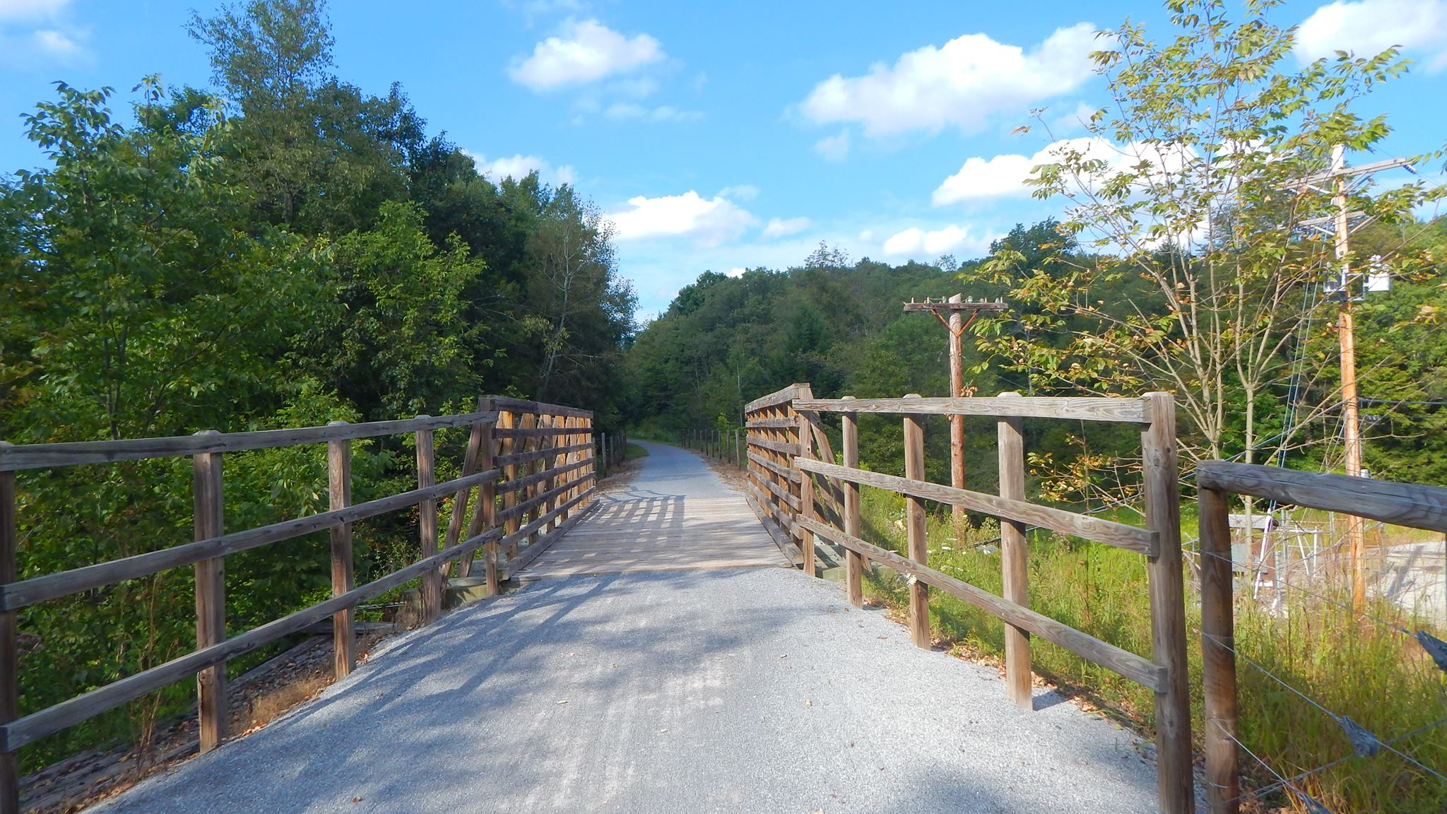

AGENDA
Cambria County Conservation & Recreation Authority
8:30 a.m., June 21, 2024
REGULAR BOARD MEETING

- Call to Order

- Pledge of Allegiance

- Roll Call

- Additions or Corrections to the Agenda by Board Members

- Floor Open to Public Comment on Agenda Items (including additions or corrections to the Agenda; Please clearly state your name)

- Commissioner’s Representative Report

- Correspondences:

  - None.

- Motion to Approve the Minutes of the May 17, 2024 Regular Board Meeting:

  - Corrections or Changes:

- Motion to Approve the Treasurer’s Report and Bills to be paid for the Month of June 2024:

  - Corrections or Changes:

- INFORMATIONAL ITEMS:

  - Maintenance Specialist Report

    - Report on the status of trail maintenance and development.

  - Program Coordinator Report

    - Report on the status of the Friends of the Trails Program and other trail related programming.

  - Rock Run

    - Report on updates at Rock Run.

  - Ghost Town Trail Report

    - Report on the status of AMLER grant to match DCNR grant.

    - Report on property use update at Red Mill Road/PA Watersheds grant.

    - Report on washout between Twin Rocks and Vintondale/Chapter 105 application/Chapter 11 Permit.

    - Report on the status of the Joseph Dushaw bequest.

    - Report on the status of washouts along the trail.

    - Report on the status of guiderail along Beulah Road.

  - Path of the Flood Trail Report

    - Report on trail signage through 9/11 Memorial Trail and South Fork Historical Society.

    - Report on potential COLCOM grant.

    - Report on 9/11 Trail Alliance Grant

  - Jim Mayer Riverswalk Trail Report

    - Report on progress of Jim Mayer Bridge Street trailhead project.

    - Report on washouts along the Jim Mayer Trail.

  - Updates on Johnstown Urban Connectivity Projects

    - Report on Path of the Flood side.

    - Report on Jim Mayer Riverswalk side.

- NEW BUSINESS:

  - Bill of Sale, Release and Indemnity Agreement
Motion to enter into a bill of sale, release, and indemnity agreement with Cambria County, to transfer and convey all of its rights, title, and interest, in and to 4 surplus Motorola 1250 portable radios for use at Rock Run.
  - Agreement with Minetech Engineers
Motion to enter into an agreement with Minetech Engineers to do the engineering of the bony pile removal portion of the AMLER project, estimated cost of $11,365, not to exceed $12,600.

- Any further public comment (Please clearly state your name)

- ANNOUNCEMENT(S)

  - The next regularly scheduled meeting of the Cambria County Conservation & Recreation Authority will take place on Friday, July 19, 2024, at 9:30 a.m. at Duman Lake County Park, Pavilion #10, 157 County Park Road, Ebensburg, Pennsylvania.

- MOTION TO ADJOURN

