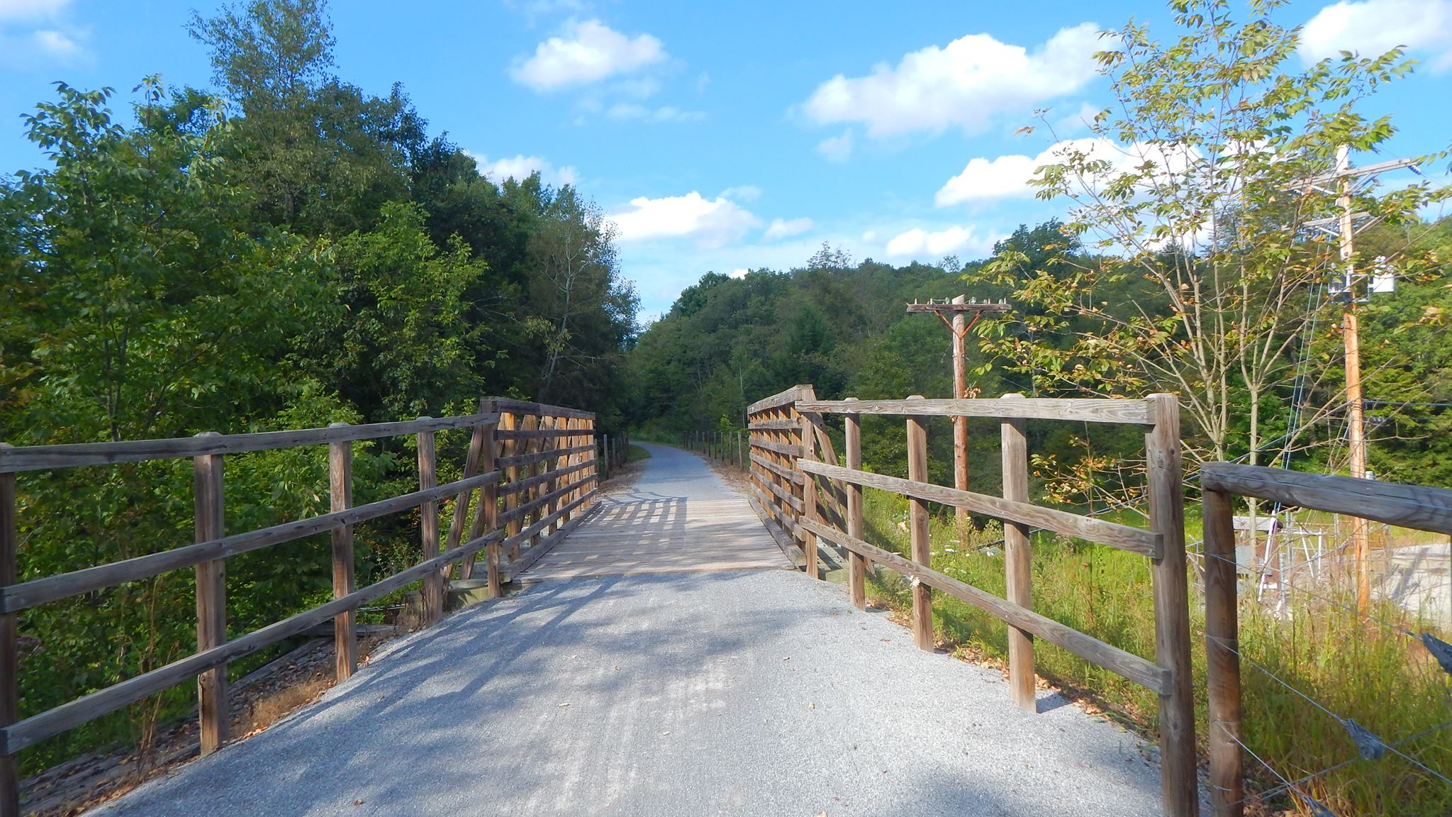

AGENDA
Cambria County Conservation & Recreation Authority
8:30 a.m., June 7, 2024
SPECIAL BOARD MEETING

- Call to Order

- Pledge of Allegiance

- Roll Call

- Additions or Corrections to the Agenda by Board Members

- Floor Open to Public Comment on Agenda Items (including additions or corrections to the Agenda; Please clearly state your name)

- Motion to approve the Minutes of the May 17, 2024 Regular Board Meeting:

  - Corrections or Changes:

- NEW BUSINESS:

  - 2023 Audit
Motion to accept the 2023 financial audit as proposed by Wessel & Co.
  - Rock Run Operating Agreement Extension
Motion to extend the current operating agreement with Rock Run Inc. until November 23, 2060.

- Any further public comment (Please clearly state your name)

- ANNOUNCEMENT(S)

  - The next regularly scheduled meeting of the Cambria County Conservation & Recreation Authority will take place on Friday, June 21, 2024, at 9:30 a.m. at Sandyvale Memorial Gardens, 80 Hickory Street, Johnstown, Pennsylvania.

- MOTION TO ADJOURN

