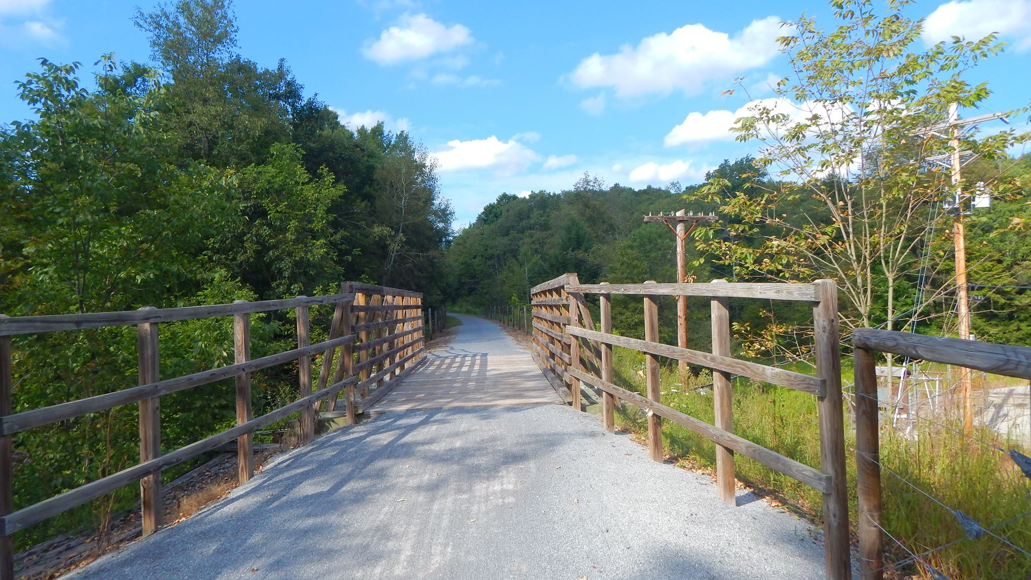

AGENDA
Cambria County Conservation & Recreation Authority
9:30 a.m., July 19, 2024
REGULAR BOARD MEETING

- Call to Order

- Pledge of Allegiance

- Roll Call

- Additions or Corrections to the Agenda by Board Members

- Floor Open to Public Comment on Agenda Items (including additions or corrections to the Agenda; Please clearly state your name)

- Commissioner’s Representative Report

- Correspondences:

  - None.

- Motion to Approve the Minutes of the June 21, 2024 Regular Board Meeting:

  - Corrections or Changes:

- Motion to Approve the Treasurer’s Report and Bills to be paid for the Month of July 2024:

  - Corrections or Changes:

- INFORMATIONAL ITEMS:

  - Maintenance Specialist Report

    - Report on the status of trail maintenance and development.

  - Program Coordinator Report

    - Report on the status of the Friends of the Trails Program and other trail related programming.

  - Rock Run

    - Report on status of operating agreement with Rock Run.

    - Report on updates at Rock Run.

  - Ghost Town Trail Report

    - Report on the status of AML/AMD grant to match DCNR grant.

    - Report on property use update at Red Mill Road/PA Watersheds grant.

    - Report on washout between Twin Rocks and Vintondale/Chapter 105 application/Chapter 11 Permit.

    - Report on the status of the Joseph Dushaw bequest.

    - Report on the status of washouts along the trail.

  - Path of the Flood Trail Report

    - Report on trail signage through 9/11 Memorial Trail and South Fork Historical Society.

    - Report on 9/11 Trail Alliance Grant

  - Jim Mayer Riverswalk Trail Report

    - Report on progress of Jim Mayer Bridge Street trailhead project.

    - Report on washouts along the Jim Mayer Trail.

  - Updates on Johnstown Urban Connectivity Projects

    - Report on Path of the Flood side.

    - Report on Jim Mayer Riverswalk side.

- NEW BUSINESS:

  - Bid Award to Cottle’s Asphalt Maintenance Inc.
Motion to award the construction of Phase 1 of the C & I 1.5 mile Extension box culvert and trail building in the amount of $777,343.90 to Cottle’s Asphalt Maintenance Inc., pending DCNR and solicitor review.
  - Agreement with Keller Engineers
Motion to add Keller Engineers for construction inspection on the 1.5 mile extension project in the amount not to exceed $211.526.80.
  - Added Engineering Services from Keller Engineering
Motion to accept proposals from Keller Engineers to do the extra engineering services, environmental permits and temporary traffic signal design associated with the concrete beam superstructure (i.e. bridges) in the amount not to exceed $58,000.00.

- Any further public comment (Please clearly state your name)

- ANNOUNCEMENT(S)

  - The next regularly scheduled meeting of the Cambria County Conservation & Recreation Authority will take place on Friday, August 16, 2024, at 9:30 a.m. at Rock Run Recreation, 1228 St. Lawrence Rd., Patton, Pennsylvania.

- MOTION TO ADJOURN

