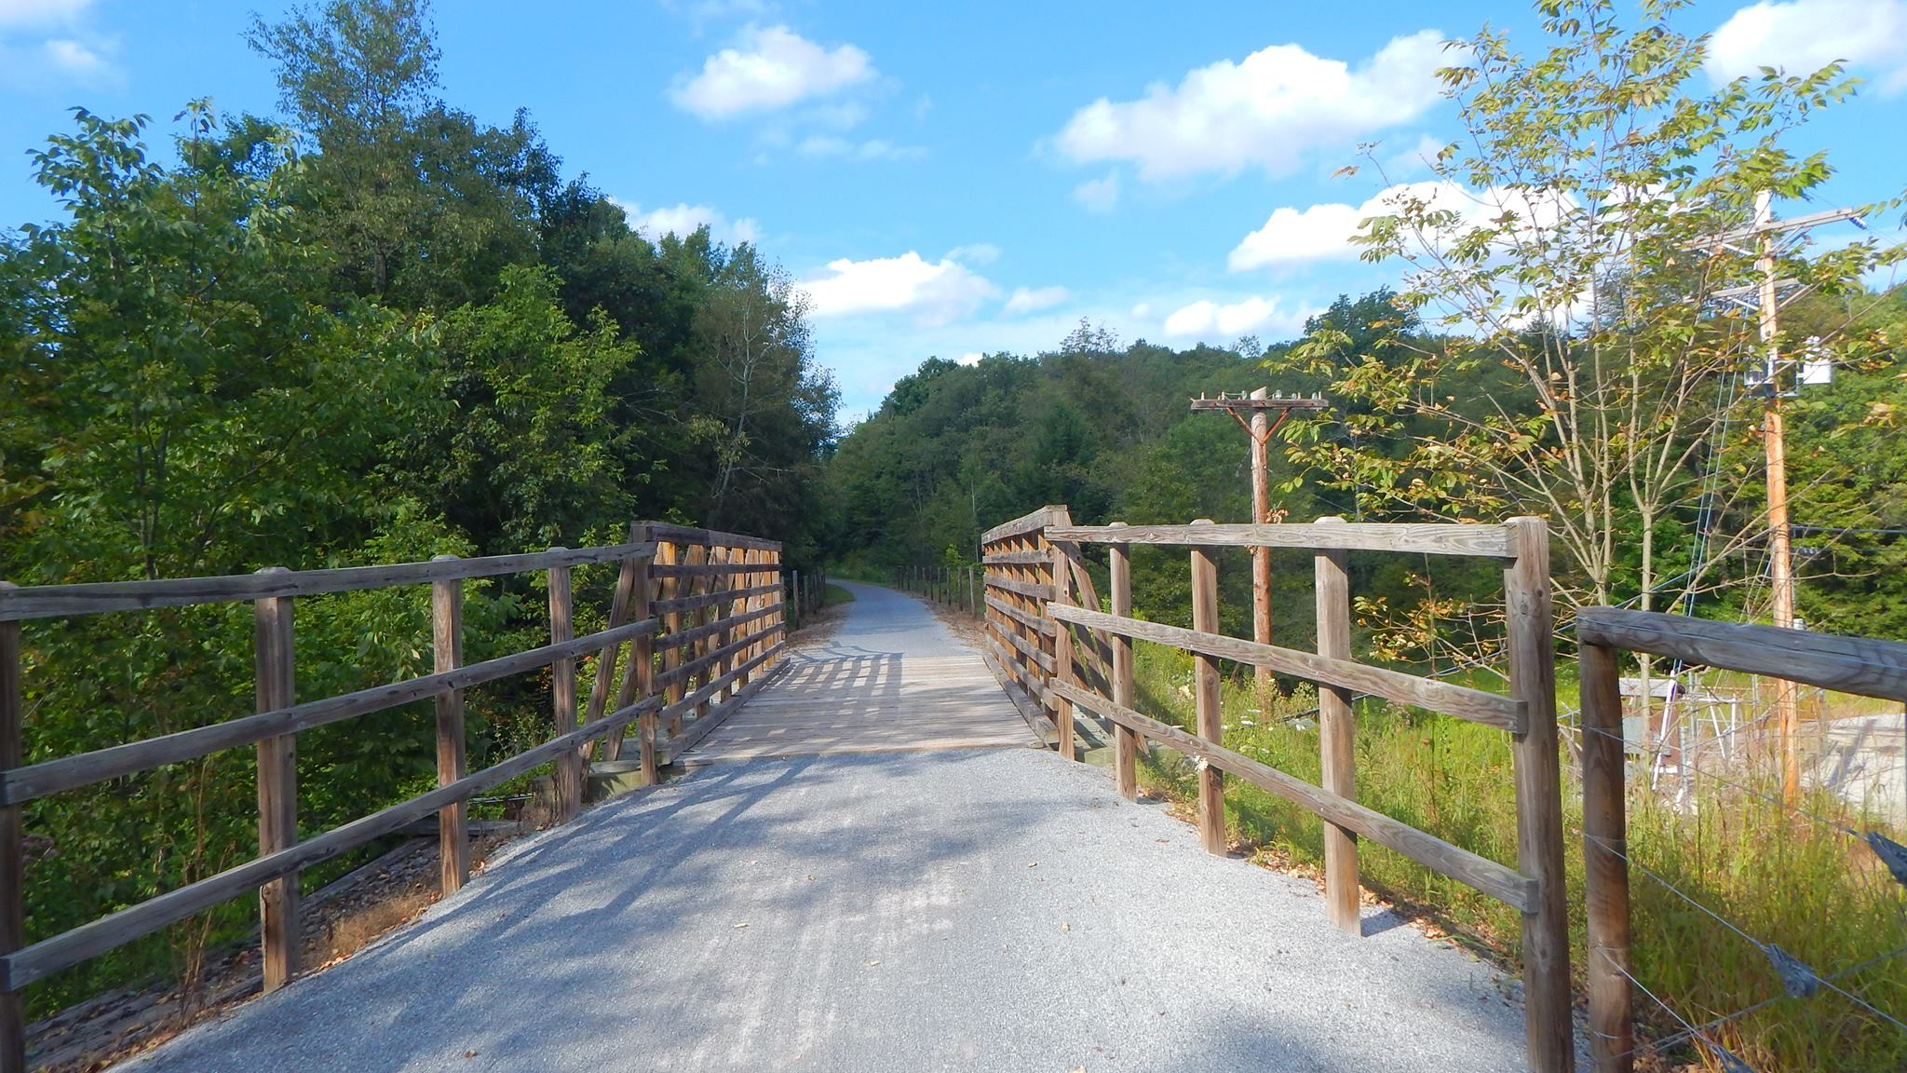

AGENDA
Cambria County Conservation & Recreation Authority
8:30 a.m., October 1, 2024
SPECIAL BOARD MEETING

- Call to Order

- Pledge of Allegiance

- Roll Call

- Additions or Corrections to the Agenda by Board Members

- NEW BUSINESS:

  - Storm Water Pipe
Motion to approve Snyder Excavating LLC, 2824 William Penn Ave., Johnstown, PA 15909 to replace the storm water pipe on the Ghost Town Trail, pending approval from appropriate sources.
  - Terms and Conditions of Awarded Grant
Motion to sign a resolution from the Department of Conservation and Natural Resources for a maintenance and rehabilitation grant in the amount of $100,000.

- ANNOUNCEMENT(S)

  - The next regularly scheduled meeting of the Cambria County Conservation & Recreation Authority will take place on Friday, October 18, 2024, at 8:30 a.m. at the Young Peoples Community Center, 300 Prave St., Ebensburg, Pennsylvania.

- MOTION TO ADJOURN

