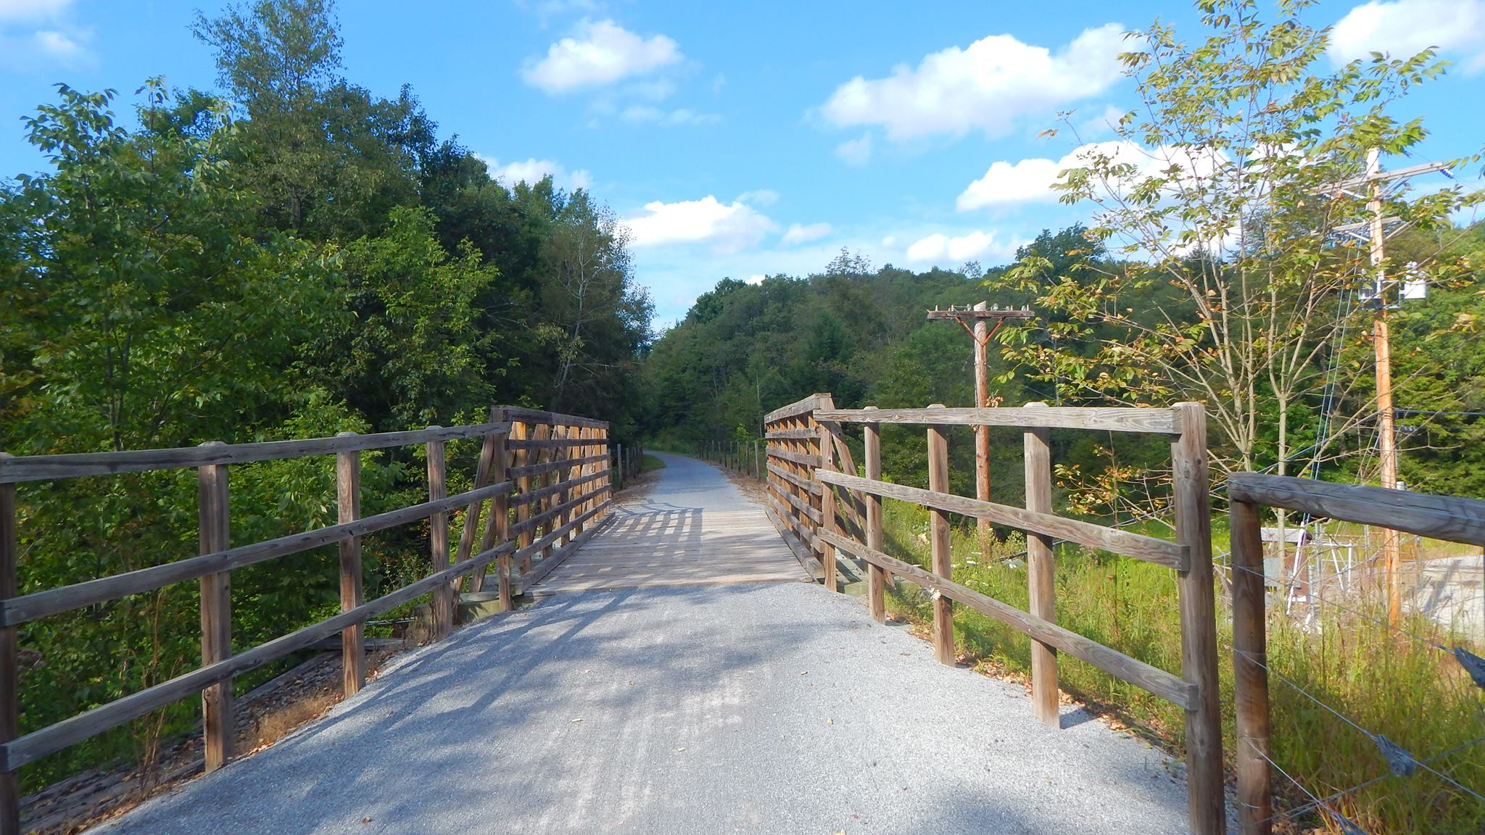

AGENDA
Cambria County Conservation & Recreation Authority
8:30 a.m., January 17, 2025
REGULAR BOARD MEETING

- Call to Order

- Pledge of Allegiance

- Roll Call

- Additions or Corrections to the Agenda by Board Members

- Floor Open to Public Comment on Agenda Items (including additions or corrections to the Agenda; Please clearly state your name)

- Commissioner’s Representative Report

- Correspondences:

  - None.

- Motion to Approve the Minutes of the December 20, 2024 Regular Board Meeting:

  - Corrections or Changes:

- Motion to Approve the Treasurer’s Report and Bills to be paid for the Month of January 2025:

  - Corrections or Changes:

- INFORMATIONAL ITEMS:

  - Maintenance Specialist Report

    - Report on the status of trail maintenance and development.

  - Program Coordinator Report

    - Report on the status of the Friends of the Trails Program and other trail related programming.

  - Rock Run

    - Report on status of wind farm construction at Rock Run.

    - Report on updates at Rock Run.

  - Ghost Town Trail Report

    - Report on the AMLER/DCNR construction update.

    - Report on Twin Rocks pipe repair.

    - Report on updates of Debby’s damage.

    - Report on the status of the Ghost Town Trail rest area.

    - Report on meetings with Saint Francis University for trail development.

    - Discussion on uses for the Langerholc trail maintenance grant.

  - Path of the Flood Trail Report

    - Report on trail signage through 9/11 Memorial Trail and South Fork Historical Society.

    - Report on 9/11 Trail Alliance Grant.

  - Jim Mayer Riverswalk Trail Report

    - Report on progress of Jim Mayer Bridge Street trailhead project picnic tables.

  - Updates on Johnstown Urban Connectivity Projects

    - Report on Path of the Flood side.

    - Report on Jim Mayer Riverswalk side.

  - Discussion on Maintenance position

- NEW BUSINESS:

  - None.

- Any further public comment (Please clearly state your name)

- ANNOUNCEMENT(S)

  - The next regularly scheduled meeting of the Cambria County Conservation & Recreation Authority will take place on Friday, February 21, 2025, at 8:30 a.m. at the Young Peoples Community Center, 300 Prave St., Ebensburg, Pennsylvania.
- MOTION TO ADJOURN

